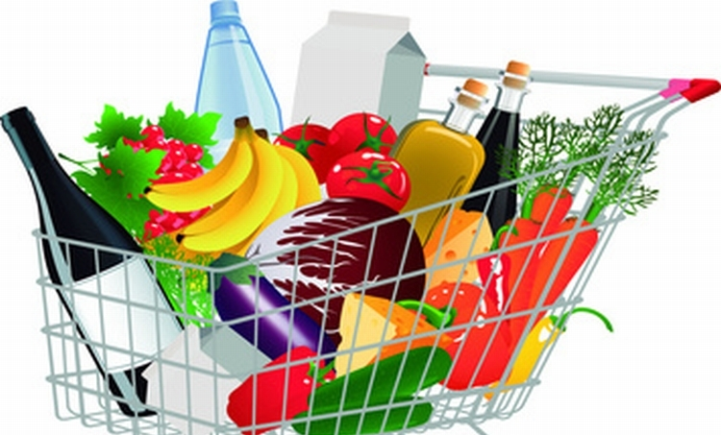

**¡**

**¡**

**Instrucciones: En tu salón de clases, con la ayuda de tu pareja elabora un listado con V y en tu hogar con la ayuda de tus padres responde la columna B   
V B**

**V V**

1______________________________________2______________________________________3______________________________________4______________________________________5______________________________________6______________________________________7______________________________________8______________________________________9______________________________________10_____________________________________11_____________________________________12_____________________________________13_____________________________________14_________________________________________________________________________________________________________________________________________________________________________________________________________________________________________________________________________________________________________________________________________________________________________________________________________________________________________________________________________________________________________________________________________________________________________________________________________________________________________________________________________________________________________________________________________________________________________________________________________________________________________________________________________________________________________________________________________________________________________________________________________________________________________________________________________________________________________________________________________________________________________________________________________________________________________________________________________________________________________________________________________________________________________________________________________

1______________________________________2______________________________________3______________________________________4______________________________________5______________________________________6______________________________________7______________________________________8______________________________________9______________________________________10_____________________________________11_____________________________________12_____________________________________13_____________________________________14_________________________________________________________________________________________________________________________________________________________________________________________________________________________________________________________________________________________________________________________________________________________________________________________________________________________________________________________________________________________________________________________________________________________________________________________________________________________________________________________________________________________________________________________________________________________________________________________________________________________________________________________________________________________________________________________________________________________________________________________________________________________________________________________________________________________________________________________________________________________________________________________________________________________________________________________________________________________________________________________________________________________________________________________________________

**´**